**[ Note: This exam contains 4 question in the following 3 pages]**

**Q1) Signed Numbers**

1- For the given 4-bit number 1100, What is the decimal value in case of using:

a) Signed magnitude representation

b) 1’s complement representation

c) 2’s complement representation

2- Calculate the results of the following 4-bit expressions using 1’s complement and 2’s complement

a) y = 6-4

b) y = 2-7

**Q2) Flip Flops**

1- Plot the SR Latch circuit

2- Explain the behavior of SR latch

3- How to convert SR latch into D Flip flop?

4 Given the following T-Flip flops

1. Plot the signals of Qo and Q1 with respect to the clk signal.
2. What is the function of this circuit?

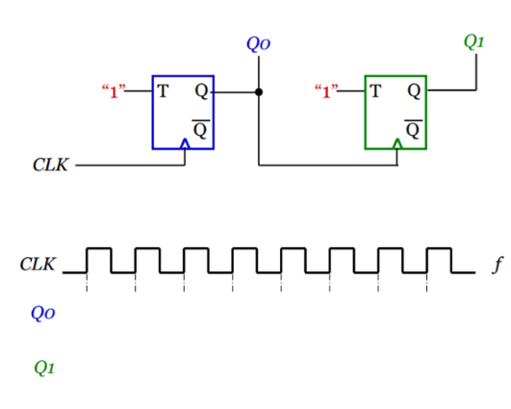

**Q3) State machine**

1. Design a 2-bit binary counter using D flip-flops
2. Do different state assignment result in similar hardware design?
3. Is it possible to explore all possible state assignment?
4. What is “state minimization”?
5. How can two states be equivalent?
6. Given the following state diagram; construct the state table and perform state minimization

**Q4) Arduino CTC101, Select the correct answer of the followings:**

**1- Arduino IDE consists of 2 functions. What are they?**

A. Build() and loop()

B. Setup() and build()

C. Setup() and loop()

D. Loop() and build() and setup()

**2- delay(5000); stands for**

A. Wait 5 minutes

B. Wait 5 seconds

C. Wait 50 seconds

**3- digitalWrite(13, LOW); turns the light**

A. on

B. off

C. dim

**4- How long is the LED on?**

digitalWrite(13, HIGH);

delay(1000);

digitalWrite(13, LOW);

delay(1000);

A. 1000 seconds

B. 100 seconds

C. 1 second

D. 100 milliseconds

**5. Which symbol ends a statement?**

A. Semicolon

B. Parenthesis )

C. Comma,

D. Curly Brace }